

SCHOOL OF ACCOUNTANCY

BKAA2013 AUDIT AND ASSURANCE 1

SECOND SEMESTER 2015/2016

INDIVIDUAL ASSIGNMENT

AMTEK HOLDINGS BERHAD

GROUP A

PREPARED BY:

ABDUL MUIZ BIN ZAMRI

233081

PREPARED FOR:

DR. ROSE SHAMSIAH BT SAMSUDIN

**QUESTION 1**

* 1. Name the entity understudy. How did you obtain the annual report? (1mark)

The entity that I obtained from The Malaysian Bourse is Amtek Holdings Berhad. After get recognition from my lecturer, Dr. Rose Shamsiah Bt Samsudin, I picked this company and continued my individual project. I obtained the annual report of this company from The Malaysian Bourse website under section company announcement which was the report are more reliable.

* 1. Based on the types of industries classified by the Malaysian Bourse, your chosen entity falls into which category? Why did it fall into such category? (2 marks)

My chosen entity fallen into consumer products industry. This company fall into this category because the vision of the company itself say that this company want to be a key player in the consumer related market and they are committed to achieving this goal.

**QUESTION 2**

**2.1** From either the hardcopy or the website, what is the image your entity is likely or trying to project? Give your views on this. (2 marks)

My view is according to the company’s website, where the company want to portray themselves as the professional consumer company where they put clearly and objectively their company’s vision, mission and goal. The company also straightforward show that they want to continuously improve their business processes to achieve their effective and efficient objective which is delivering highest and reliable performance to their shareholders and customers.

**2.2** Based on the overall content of the report, how did your chosen entity segment (classify) all the information? What are the statutory and voluntary disclosures of items or information? Give examples of them. (6 marks)

According to Nacra Malaysia 2015, *“all additional disclosure beyond the statutory requirements which are useful for understand the financial statements are encouraged”*, due to that, my chosen entity have classified all the information by making the statutory disclosure which was solemnly declare by Mr. Tan Huey Huey, the officer that primarily responsible for the financial management of Amtek Holdings Berhad.

Statutory disclosure is a written statement that allows a person to declare something to be true. As example, when you make a statutory declaration, you are declaring that the statements in it are true. If you intentionally make a false statement in a declaration, you can be charged with an offence.

However, voluntary disclosure is the provision of information by a company's management beyond requirements such as generally accepted accounting principles (GAAP), where the information is believed to be relevant to the decision-making of users of the company's annual reports.

**2.3** Who is responsible for the preparation of the financial statements in the annual report? State the provision under the Companies Act which prescribes for the requirement to have the financial statements audited. (3 marks)

There are 2 persons that responsible for the preparation of the financial statements in the annual report which hold the position as the directors of Amtek Holdings Berhad, Tuan Syed Azmin Bin Mohd Nursin @ Syed Nor and Mr. Thong Teong Bun.

The company’s statement that state the provision under the Companies Act which prescribes for the requirement to have the financial statements audited**:**

1. *In our opinion, the accounting and other records and the registers required by the Act to be kept by the Company and its subsidiary companies of which we have acted as auditors have been properly kept in accordance with the provisions of the Act.*
2. *We are satisfied that the financial statements of the subsidiary companies that have been consolidated with the Company’s financial statements are in form and content appropriate and proper for the purposes of the preparation of the financial statements of the Group and we have received satisfactory information and explanations required by us for those purposes.*
3. *Our audit reports on the financial statements of the subsidiary companies did not contain any qualification or any adverse comment made under Section 174(3) of the Act, except for the reports of certain subsidiary companies which have included an emphasis of matter as disclosed in Note 6 to the financial statements.*

**QUESTION 3**

**3.1** What is the content of financial statements enclosed by your entity? Are they similar to what you would find in the text book? Explain. (3 marks)

The content of the company’s financial statements is**:**

* 1. Statement of Comprehensive Income,
  2. Statement of Financial Position,
  3. Statement of Changes in Equity,
  4. Statement of Cash Flows and
  5. Notes to the Financial Statements.

The financial statement that contain in the company’s annual report is similar to what I will find in the textbook because this company follow the standard, Malaysian Financial Reporting Standards (MFRS) in preparing the financial statement.

**3.2** Comment on the format of the financial statements? Is there any standard format that entity has to follow? (4 marks)

From my point of view, the format of the financial statements of the company is properly drawn up in accordance with Malaysian Financial Reporting Standards (MFRS), International Financial Reporting Standards (IFRS) and the Companies Act.

Since the company are listed in The Malaysian Bourse, they need to follow the standard format which are listed in rules and regulations such as Malaysian Financial Standards (MFRS), International Financial Reporting Standards (IFRS) and the Companies Act, 1965 in Malaysia.

**3.3** Comment on the financial information provided by the entity? Are they adequate? State your reason (s) or justification (s). (3 marks)

Adequate disclosure is the concept where all the essential information is included in the financial statement of the company. So, according to the company’s financial statement, the information provided by the entity is adequate. It is because all the information in the financial statement are clearly stated.

For example, the entity has prepared the Notes to the Financial Statement to explain in details on how the words and numbers figure appear in the financial statements. It can help for better understanding for the users to evaluate the financial statements to make financial decisions.

**3.4** Does the entity have sound financial standing? How about the non-financial performance? Support your answers with some analysis. (8 marks)

**PROFITABILITY RATIO:**

1. **OPERATING MARGIN**

$$= \frac{OPERATING PROFIT}{NET SALES}$$

|  |  |
| --- | --- |
| 2014 | 2015 |
| $$= \frac{-413381}{56212}$$ = -7.35 | $$= \frac{-688356}{55036}$$ = -12.51 |

1. **RETURN ON ASSETS**

$$= \frac{NET INCOME}{TOTAL ASSET}$$

|  |  |
| --- | --- |
| 2014 | 2015 |
| $$= \frac{-413381}{10247999}$$ = -0.40 | $$= \frac{-688356}{9581990}$$ = -0.07 |

On the financial part, according to A, we can see that the company having an increment in loss from 2014 to 2015 for each RM1 of sales. In another view, non-financial part, as stated in B, the company also having a loss in every RM1 of assets investment in the company from 2014 to 2015. This trend analysis shows that the company having bad performance in both financial and non-financial.

**QUESTION 4**

**4.1** Did the entity enclose the Auditor Report? Where is it placed in the annual report?

(2 marks)

Yes, this entity did enclose the Auditor Report. They place the auditor report in page 29 in the annual report with tittle “Independent Auditor’s Report”. This audit report gives a review about the director’s responsibility for financial statement and auditor’s responsibility. It also expresses the auditor’s opinion about the presented financial statements either the financial statement gives a true and fair view or not.

**4.2** Who audited the financial statements? Whom do the Auditor report addressed to and name the firm/auditor (if possible). (2 marks)

The person who audited the financial statements is Peter Chong Ton Nen, a chartered accountant and the audit report is addressed to the audit firm, Peter Chong & Co, Chartered Accountant from Bukit Bintang, Kuala Lumpur.

**4.3** What type of audit report was issued? Why is it so? State your reason (s). (4 marks)

The audit report that was issued by the auditor is an unqualified report. My reason is because the company have presented true and fair view financial statements which according to the Malaysian Financial Reporting Standards (MFRS) and Malaysian Companies Acts 1965.

Besides that, the financial statements are free from material misstatement whether it is due to the fraud or error and also believed that the director is responsible of the internal control.

**4.4** List out the entity’s subsidiaries (if possible). Did they have the same auditor? Were their accounts qualified (or otherwise)? (3 marks)

The entity’s subsidiary is Power Wave Sdn. Bhd. and Apparel International Sdn. Bhd.The subsidiary company have been audited under the same auditor because their financial activities are included in this annual report (refer to Notes to the Financial Statement, note 14, the annual report page 64). Their accounts report is not a qualified report but is an unqualified report because their financial transaction and information are all included in this financial statement in the company’s annual report.

**QUESTION 5**

**5.1** Has the entity established an Audit Committee? When was it formed? State two (2) differences between External Auditor and the Audit Committee. (4 marks)

Yes, this entity has established its own audit committee in 25 August 2014. The differences between external auditor and the audit committee is external auditor does not have conflict of interest and bias towards the company while the audit committee is an internal audit function in the company and has high probability of having conflict of interest.

Besides that, external auditor has ability to gain public confidence and can make the audited financial statement be more reliable for users to make financial decision while the audit committee cannot perform formal audit on the financial statement of the company and cannot gain public confidence because public concern that they might have conflict of interest.

**5.2** Did the entity list out names of the members? Are they independent or non-independent members? What is your view on the composition of members? (3 marks)

Yes, the entity listed out names of the members (may refer to the annual report, page 10)**:**

1. Mr. Thong Teong Bun
2. Encik Ahmad bin Abu Bakar
3. Encik Wan Rashid bin Dato’ Wan Mohamed

All the audit committee is independent non-executive director members. From my point of view, the composition is good enough because since all of them are independent member, so the opinion and thought in making decision maybe will be various and differently between them.

**5.3** Did your entity state the Audit Committee’s terms of reference (TOR) or charter? Describe the functions of audit committee. (3marks)

Yes, this entity did state the terms of reference (TOR) in the page 10 in the annual report. The function of audit committee is to review the audit plan and report also make an evaluation on the company’s internal control along with the external auditor to make report to the Board of Directors. Next, the audit committee used to evaluate the system given by the company to the external auditors and also function to reviews the financial result or statements such as quarterly or annually and ensures that it is compliance with the standard needs.

**5.4** Under what legislation is the formation of an Audit Committee is a MUST? Justify the importance of the existence of an audit committee to the entity. (3 marks)

The formation of an Audit Committee must follow to Bank Negara Malaysia’s guideline. Where stated in this guideline it has say that**:**

“*These Guidelines represent the minimum expectations of Bank Negara Malaysia*

*(the Bank) with regard to the establishment and scope of work of audit committees*

*and internal audit departments, and lay down minimum internal audit standards for*

*insurance companies.”*

The importance of the existence of an audit committee is to ensure that the internal control of the company works as they required. Then, the audit committee is very important because they help to report of any material misstatement or fraud on the financial statements to the director before giving the financial statements to external auditor to perform audit thus to produce audit report. Besides that, the audit committee also important to ensure the financial statements that will be audit by the external auditor present true and fair view then they will give to the external auditor to make reassurance.

**QUESTION 6**

**6.1** What are the economic factors that might have some influence on the performance of your entity? Name three (3) and explain. (6 marks)

The economic factors that might influence the performance of this company are demands and supply, interest rate and inflation.

The demands and supply may affect this company performance. For example, if the customer’s demand of the apparel and garment product is high, so the company must supply high amount of the product thus, will increase in making the product and the sales generating by the company. However, what really happen is the revenue of the company is constant in 2014 and 2015 which mean that the demand and the supply of this company is not increase.

Next, the interest rate use by the company also affects the performance of the company such as the using of effective interest rate on impairment assets. The risk regarding to this rate is that the fair value or the future cash flow of the company’s financial instrument will fluctuate according to changes in the market interest rate.

Lastly, the rate of country’s inflation might also affect the company’s performance. The Malaysia’s rate of inflation is not something that the company can control because it can be the external factor. If the inflation rate is high, then the company have to find the way to cope with the inflation rate or else it will affect the company’s performance badly.

**6.2** Is there any development on current local rules, regulations, acts which your entity should be concerned about? Name two (2) and explain. (6 marks)

Yes, there is a development on current local rules, regulations and acts which this entity should be concerned such the implement of new sales and services tax, Goods and Services Tax (GST) and minimum wages.

Goods and services tax (GST) is value added tax in Malaysia which levied on most transactions in the production process, but is refunded with exception of Blocked Input Tax, to all parties in the chain of production other than the final consumer.

Next, the government has set the minimum wages of Malaysians’ workers which are RM900. Thus, they cannot afford to buy the apparel and garment product that produces by this company because the Malaysians’ workers have to distributed their money prior things first before they buy the product that produces by this entity.

**6.3** Name and explain at least two (2) social factors that your chosen entity should pay attention to? Explain. (6 marks)

Two social factors that my chosen entity should pay attention to is the customers’ trend and the competitors’ business strategies.

The company should give an attention to customers’ trend because nowadays the trend and lifestyle in their daily clothing are keep changing. So they must always up-to-date toward customers’ trend.

The company also must pay attention to their competitors’ business strategies. While focusing and analyse their competitors’ business strategies, they can also compare their business performance to the competitor via year based analysis or trend analysis in order to achieve their goal which is to be a key player in the consumer related market effectively and efficiently.

**QUESTION 7**

**7.1** What additional information would you like them to provide in the annual report? Support your answer. (3 marks)

From my point of view, there are several things that they have to include in the annual report in order to make the annual report is more reliable, complete and present the performance of the company as a whole.

Among of the additional information that needs to be included is the background and the reputation or history of the auditor that perform the audit on the company. Besides that, more information about the financial performance of all the subsidiaries and the group of company also can be added in order for user to make valuation.

Next, the review summary of the company financial information for the past year also can be added in the annual report. All this additional information may help users to more easily make financial decision.

**7.2** Provide two (2) suggestions on how the chosen entity may improve the quality of its annual report? (3 marks)

My suggestion is the company may improve the quality of its annual report by listing all the statutory disclosure and voluntary disclosure along with the details for users to be more understandable. Next, company may also create the review part of the function and opinion of the company’s internal audit before hand it to the external auditor to perform formal external audit.

**QUESTION 8**

**8.1** Backed with the share prices analysis (eg: share prices monitored, graphs of price fluctuations, financial ratios calculated), and previous information gathered (Auditor Report; economic, social and legislative factors; financial and performance analysis; entity’s governance etc.), if you were to own **substantial shares** of this entity, would you **retain, buy more OR sell your shares**? Justify your decision. (8 marks)

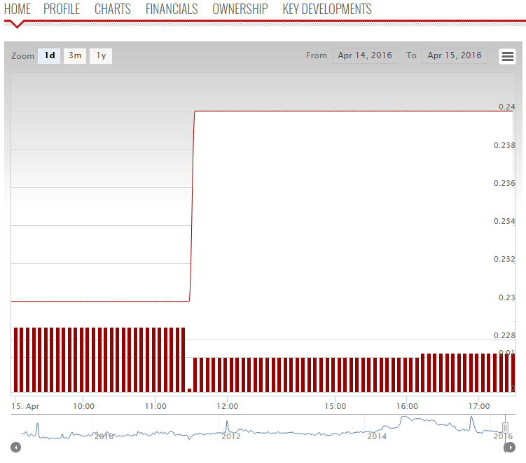

Figure 1

The figure 1 above, I get it from bursa market place website that show the share price of this entity was constant from early 2012 to 2016.

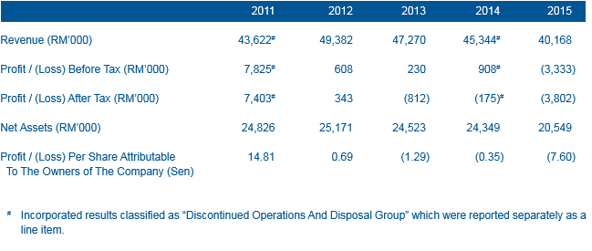

Figure 2

The figure 2 above, I get it from the financial statement in the company’s annual report where it shows that the earning per share fluctuated where start decreased from 2011 to 2013, increase in 2014 and then fall again in 2015.

So, if I were to own substantial shares of this entity, I would like to retain my shares in this company. The prior reason is because according to my analysis based on figure 1 where the share price of this company is constant in consecutive years. Even the earning per share of this company is fluctuating based on my analysis on figure 2, the company still can manage to make their share price in The Malaysian Bourse constantly where the company’s effort increases my confidence to retain and continue my investment in this entity.

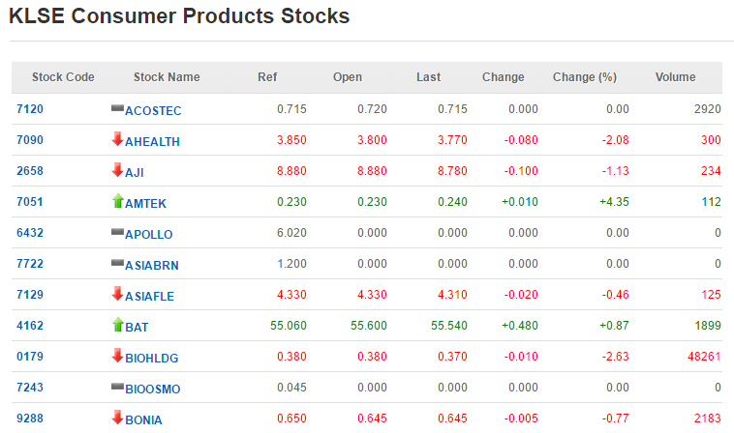

Figure 3

Even the company performance financial and non-financial is getting bad based on my analysis in question 3.4 in 2014 and 2015 and the economic, social and current development factors that affected the company, this company still can manage to holding their position at top 10 in Malaysia Consumer Products Stocks. This is my other reason on why I should retain and continue my investment in this company. We can see the proved by looking at the figure 3, where I get it from the current analysis ranking that made by Kuala Lumpur Stock Exchange (KLSE) on the KLSE website at 10.30 p.m. on 16 April 2016. This company’s stock in the consumer market make me more confidence and more believe to this company.

**REFERENCES**

1. Arens, Alvin A., Elder, Randal J., Beasley, Mark S.,Amran, N.A., Fadzil, F. H., M. Yusof, N.Z., Mohamad Nor, M.N., Shafie, R. (2014) ***Auditing and Assurance Services in Malaysia: An Integrated Approach***, 3rd Edition, Prentice Hall.
2. Prudential Financial Policy Department, Bank Negara Malaysia (31 March 2005), ***Guidelines For Audit Committees And Internal Audit Department (Part A)***, BNM/RH/GL/003-22
3. <http://www.bursamalaysia.com/market/listed-companies/company-announcements/4910893>
4. <http://www.micpa.com.my/v2/nacra/NACRA-Brochure-2015.pdf>
5. <http://www.bursamarketplace.com/index.php?ch=ch_themarket&pg=pg_tm_stocksss&ac=2033>
6. <http://www.malaysiastock.biz/Market-Watch.aspx?type=C&value=CONSUMER>